Title

SOP for Genesys agent Installation

**Prepared By**

**Helpdesk**

Date: Friday, March 1, 2019

Version 1.0

**Document History**

|  |  |  |  |
| --- | --- | --- | --- |
| Date | Author | Revision | Description |
| 01-03-2019 | Tech-helpdesk | 1.0 | Document Creation |

|  |  |  |
| --- | --- | --- |
| Approved By: | Tata Business Support Services Limited | |
|  | 1.0 | Manager-Technology |

|  |  |  |  |
| --- | --- | --- | --- |
| **Distribution List** | | | |
| Name | Department | Company | Rights |
| MN Kalyan | Technology | Tata BSS | Review & Comment |
| Ramakrishna TV | Technology | Tata BSS | Modify |
| Ali Hyder | Technology | Tata BSS | Review & Approve |

Security Classification: Tata BSS Restricted.

Procedure:

Go to run command and enter \\10.101.8.106\d$\Genesys App\genesys 126\ IP_IntWSpaceSIPEp_8511517b1_ENU_windows \ip\setup.exe

Then you will find the below window

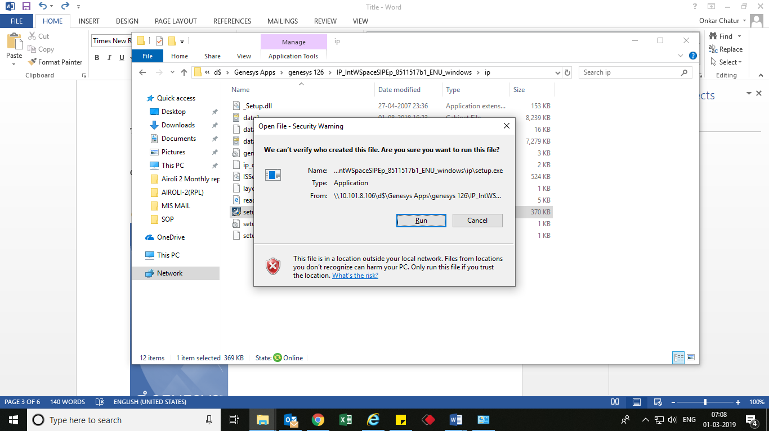

Click on Run button. You will find the below window.

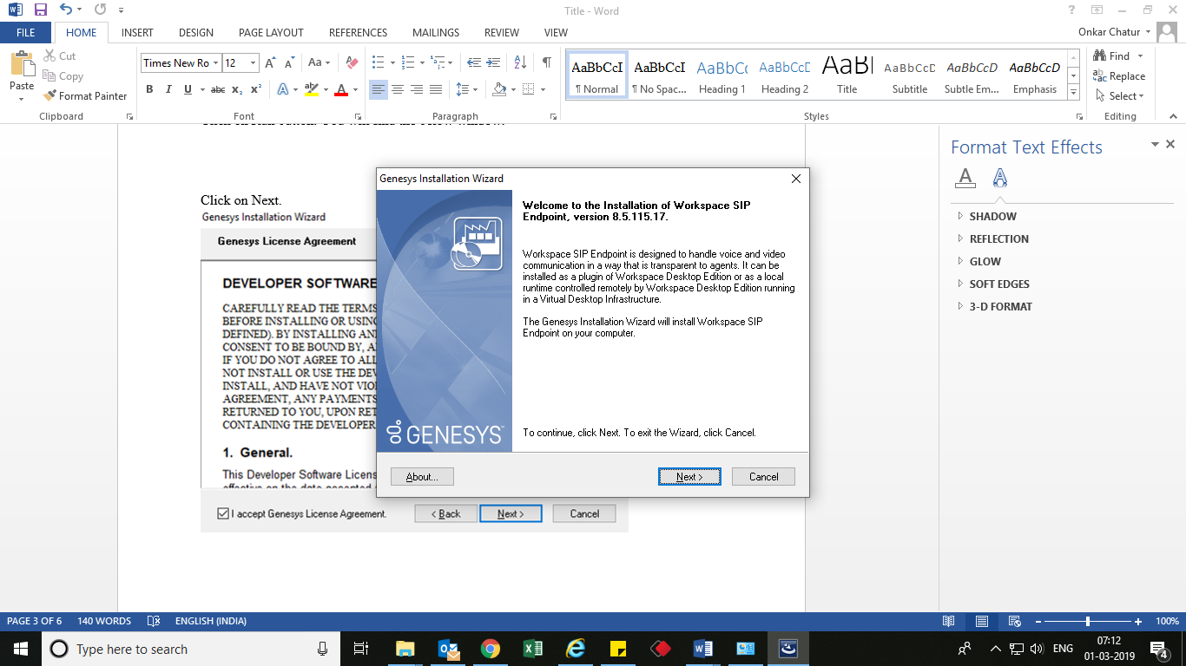

Click on Next.

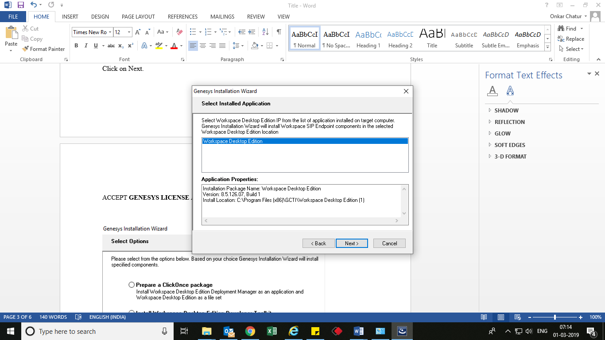

CLICK **NEXT.**

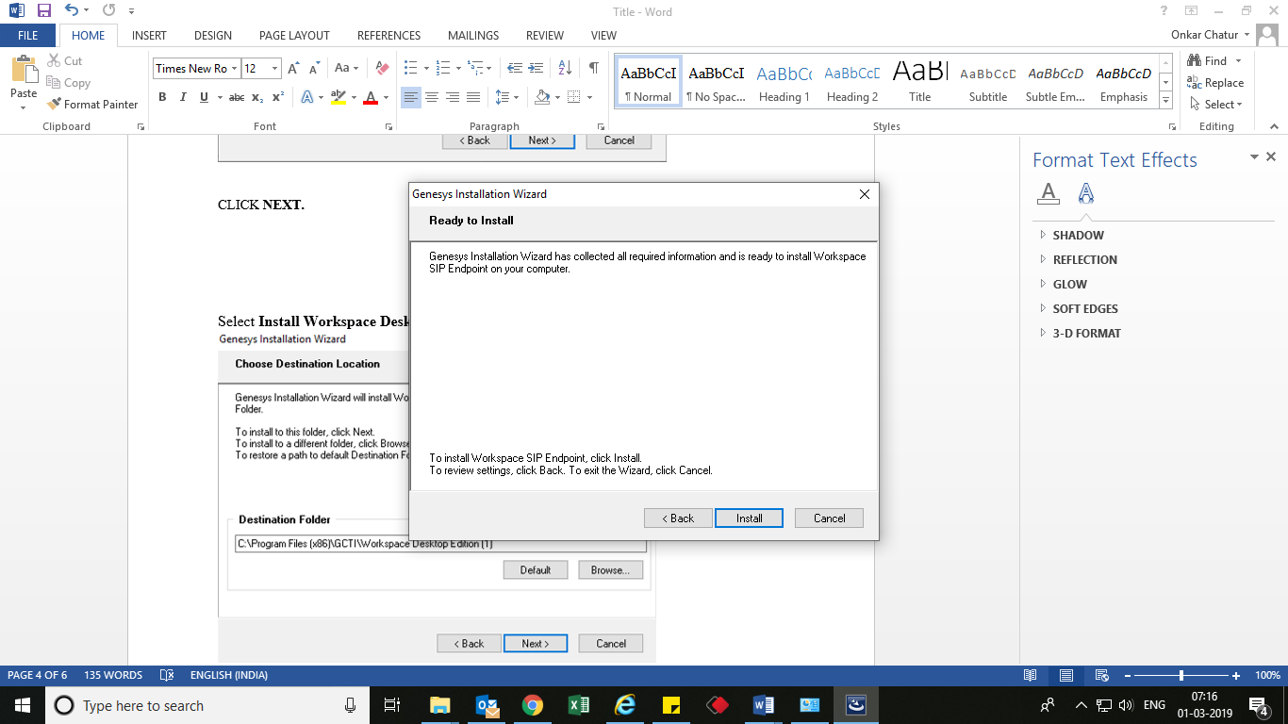

Click **Install**.

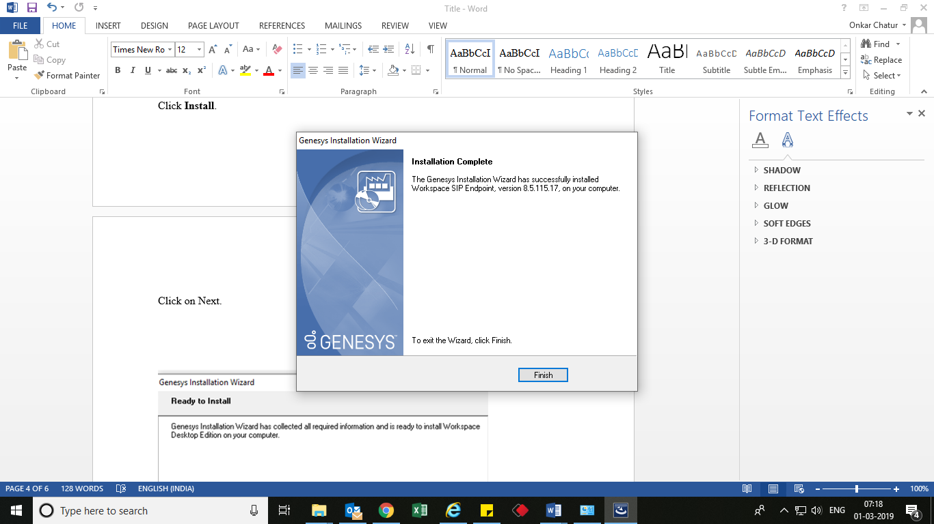

Click on **Finish**.

**THANK YOU**